**3. TWO STAGE R-C COUPLED AMPLIFIER**

**AIM:**

1. To observe the frequency response of RC coupled amplifier and to find the bandwidth of the amplifier.
2. To observe that the total voltage gain is equal to the product of the individual gains.

|  |  |  |
| --- | --- | --- |
| **APPARATUS:** |  |  |
| Power supply | 0-30V | 1No. |
| CRO | 20MHz | 1No. |
| Signal generator | 1-1MHz | 1 No |
| Resistors | 1kΩ, 4.7k, 8.2k, 33k | 2 No |
|  | 2.2k | 1 No |
| Capacitors | 10µF | 3 No |
|  | 100µF | 1 No |
| Transistors | BC107 | 2 No |

**CIRCUIT DIAGRAM:**

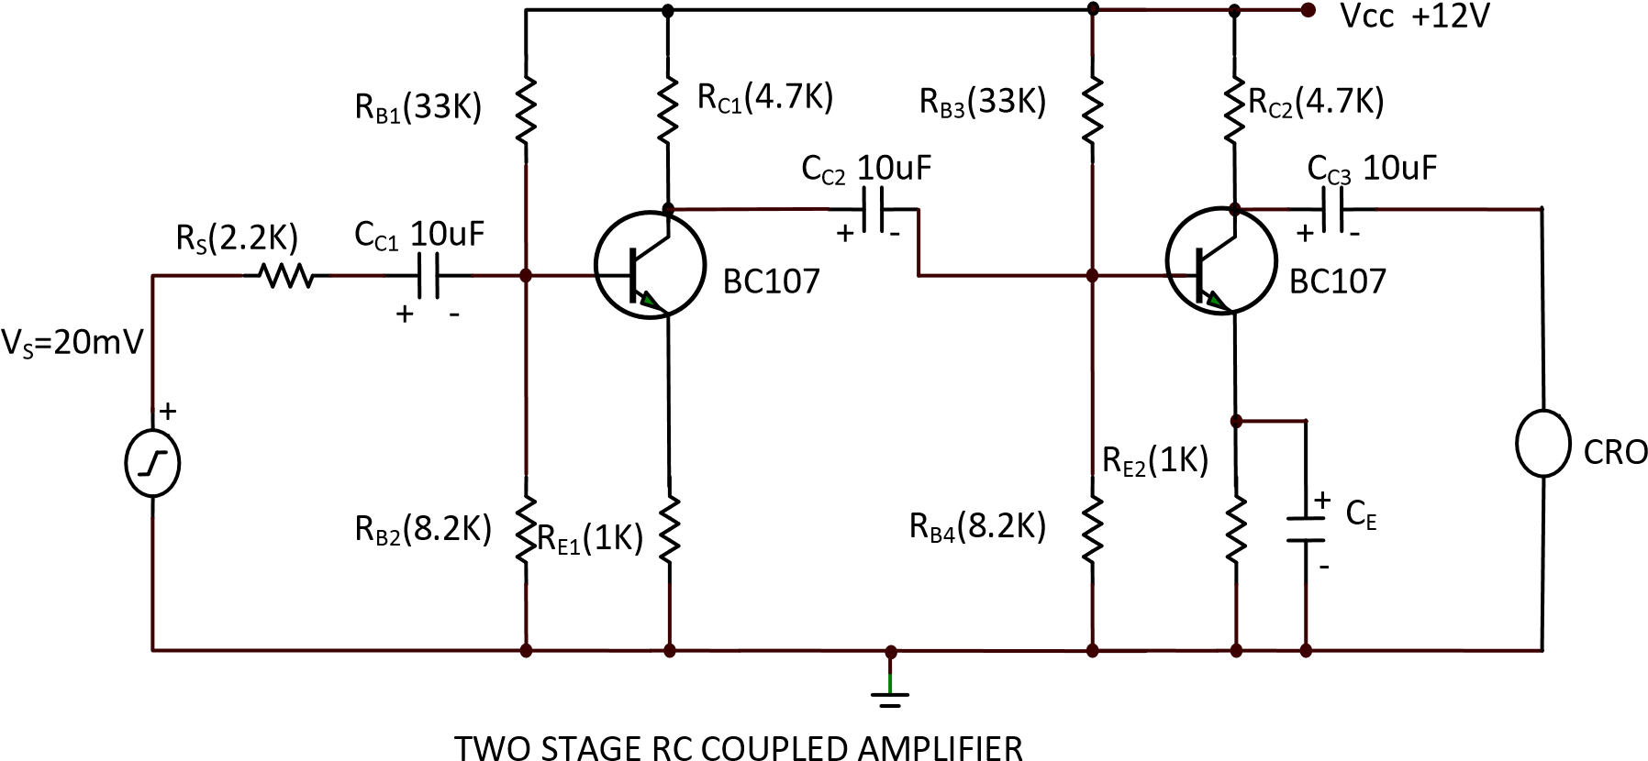

**PROCEDURE:**

* 1. Connect the circuit as shown in the figure**.**
  2. A 10V supply is given to the circuit and a certain amplitude of input signal is kept constant using signal generator.
  3. Measure the output voltage (say Vo2  )and also output voltage at the output of 1st stage

(say Vo1)from CRO.

* 1. Calculate total voltage gain and also individual voltage gain.
  2. Now, by varying the input frequency note the output voltages from CRO and calculate the gain.

**OBSERVATIONS:**

CIRCUIT DIAGRAM

WAVEFORM

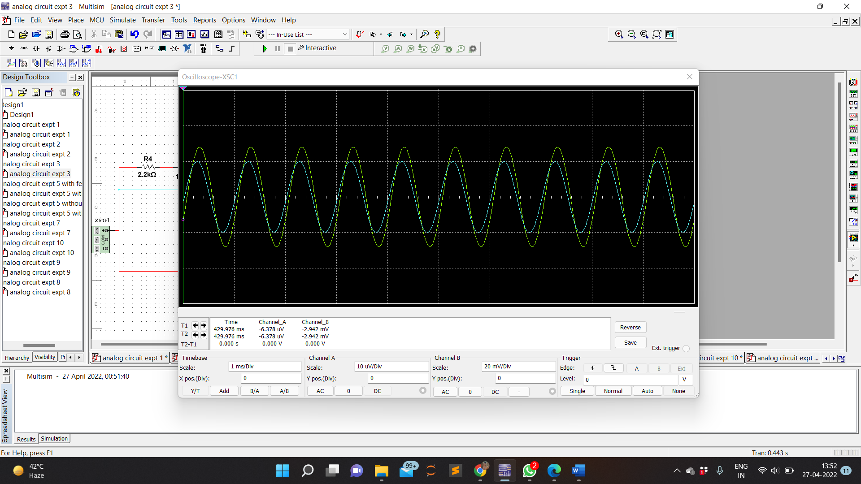

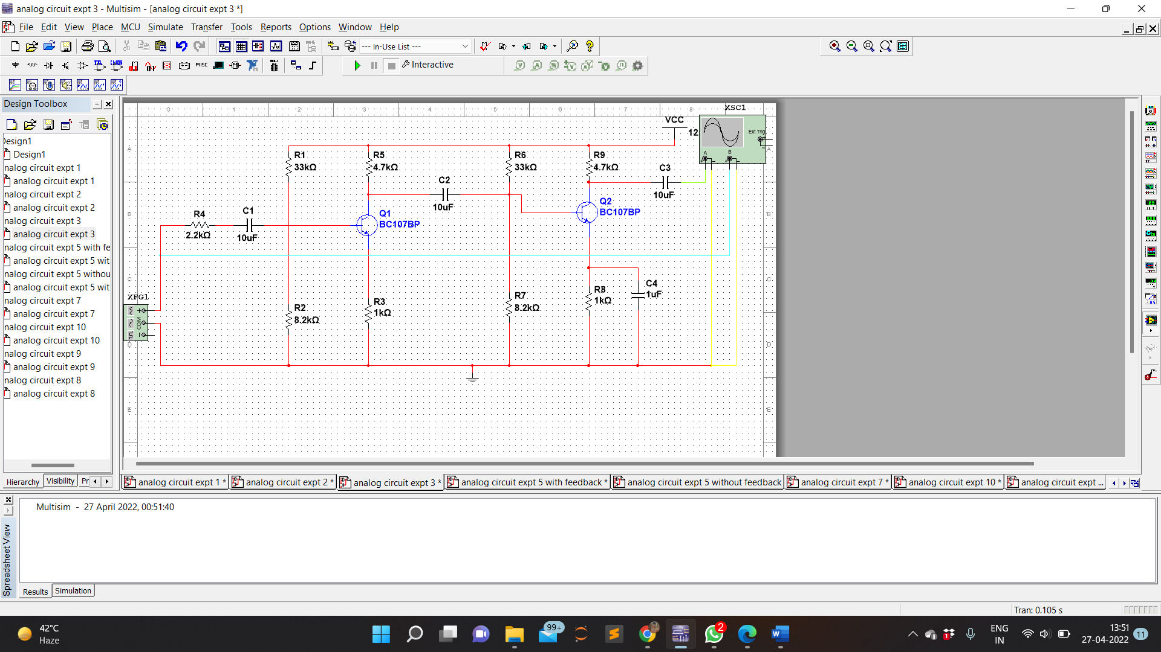OUTPUT VOLTAGE

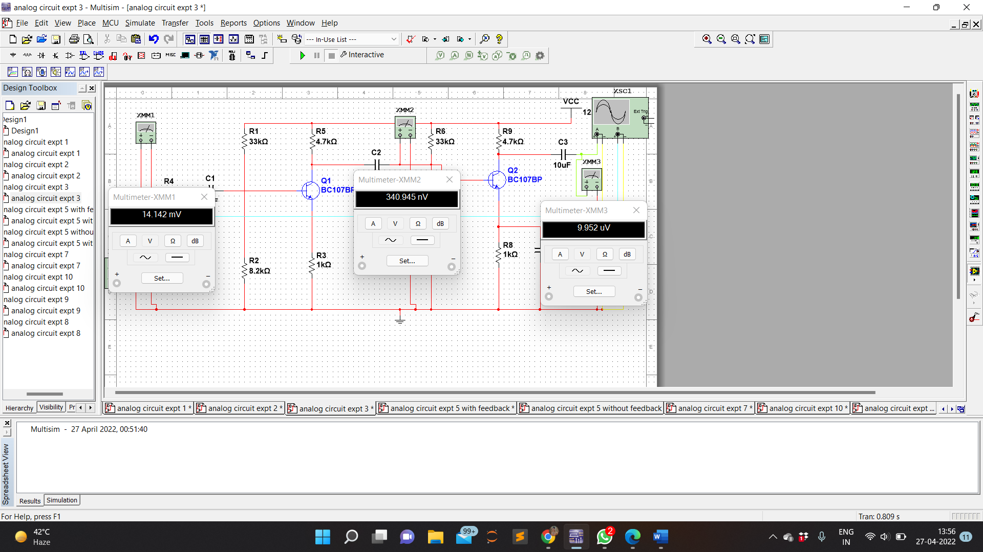

**CALCULATION:**

1. Input Frequency = 100 Hz

Output Voltage (Vo1) = 34.325 nV

Output Voltage (Vo2) = 186.697 nV

Input Voltage (Vin) = 14.412 mV

So , Voltage gain = Vo2/Vin **=** 186.697nV/14.412mV

= 0.0000129

Gain (dB) = 20 log Vo/Vin = 20 log (0.0000129)

= -97.78

1. Input Frequency = 1 kHz

Output Voltage (Vo1) = 340.945 mV

Output Voltage (Vo2) = 9.952 uV

Input Voltage (Vin) = 14.412 mV

So , Voltage gain = Vo2/Vin **=** 9.952uV/14.412mV

= 0.000690

Gain (dB) = 20 log Vo/Vin = 20 log (0.000690)

= -63.22

1. Input Frequency = 1 MHz

Output Voltage (Vo1) = 26.379 uV

Output Voltage (Vo2) = 7.008 mV

Input Voltage (Vin) = 14.412 mV

So , Voltage gain = Vo2/Vin **=** 7.008mV/14.412mV

= 0.486

Gain (dB) = 20 log Vo/Vin = 20 log (0.486)

= -6.26

Bandwidth = f**high –** f**low** = 4.2380 MHz – 109.7863 KHz = 4.1283 MHz

**TABULAR FORM:**  Vin= 14.412 mV

|  |  |  |  |
| --- | --- | --- | --- |
| **INPUT FREQUENCY**  **(Hz)** | **O/P Voltage(Vo)**  **(V)** | **Voltage gain**  **AV=Vo/Vi** | **Gain in dB =**  **20 log AV** |
| 100    1k    1M | 186.697 nV  9.952 uV  7.008 mV | 0.0000129  0.000690  0.486 | -97.78  -63.22  -6.26 |

**Model Graph:**

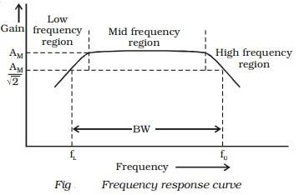

**Calculations from Graph**

1.Draw a line at maximum gain(dB) less than by 3dB parallel to the X-axis as shown in the figure

2.Draw two lines at the intersection of the characteristic curve and the 3dB line onto the X-axis which gives the (fH) and (fL)

3.The difference between fH and fL gives the Bandwidth of the amplifier.

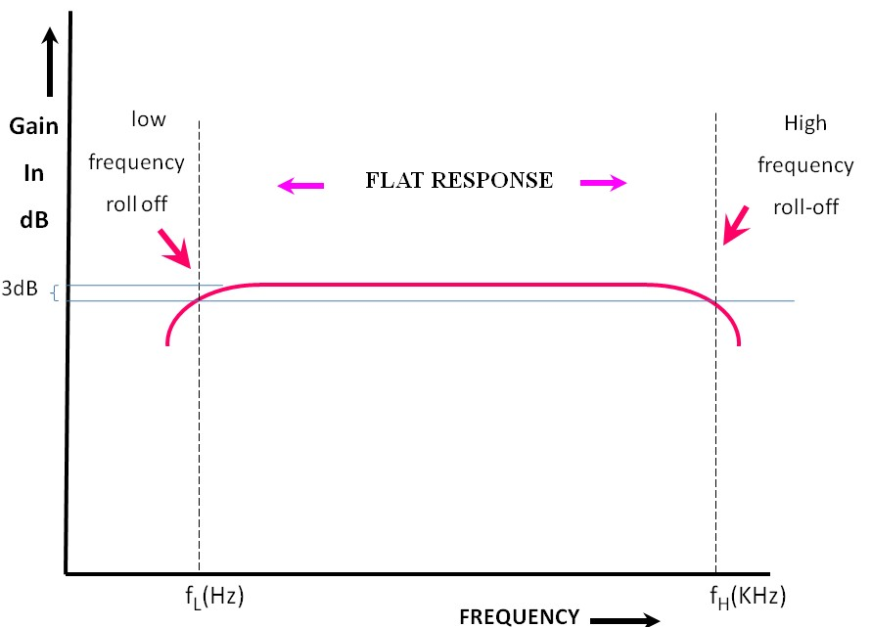

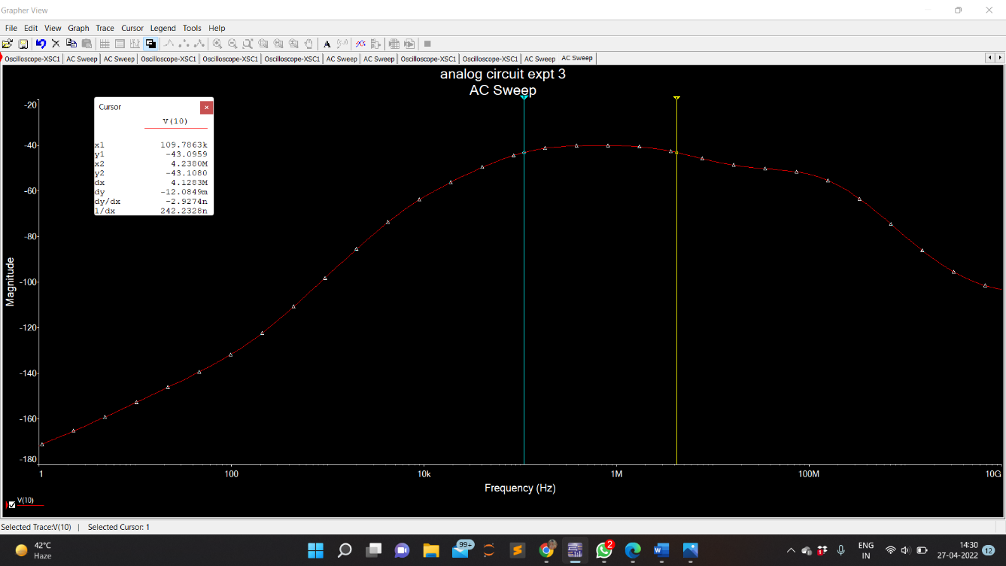

**OBSERVATIONS:**

I/P Voltage Vin = 14.412 mV

O/P Voltage Vo1 = 340.945 mV

O/P Voltage Vo2= 9.952 uV

st *Vo*1

1. Stage voltage gain=  *Vin = 23.657*

nd *Vo*2

1. Stage voltage gain  *Vo*1 = 0.0000291

*Vo*2 Overall voltage gain 

*Vin = 0.000688*

Bandwidth = *fh – fl =* 4.1283 MHz

**PRECAUTIONS :**

1. Connections must be made with proper polarity.
2. Avoid loose and wrong connections.

**RESULT:**

The frequency response of RC coupled amplifier is observed and the bandwidth of the amplifier is calculated and it is proved that the total voltage gain is equal to the product of the individual gains.